Ex No: 7 Practice with ExpressJS
Date:

Aim:
To practice the backend development framework ExpressJS

Code:

1.
const express = require("express");
const app = express();
app.get("/", (req, res) => {
res.send("Hello World from Express!");
});
app.listen(3000, () => {
console.log("Server running on http://localhost:3000");
});

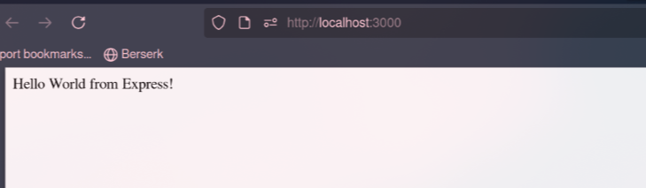
2.
const express = require("express");
const bodyParser = require("body-parser");
const app = express();
app.use(bodyParser.json());
const users = [{ username: "sethu, password: "12345" }];
app.get("/", (req, res) => {res.send("Welcome to the Login App ");
});
app.post("/login", (req, res) => {
const { username, password } = req.body;
const user = users.find(u => u.username === username && u.password === password);
if (user) {
res.json({ message: "Login successful!" });
} else {
res.status(401).json({ message: " Invalid credentials" });
}
});
app.listen(3000, () => console.log("Login app running on http://localhost:3000"));

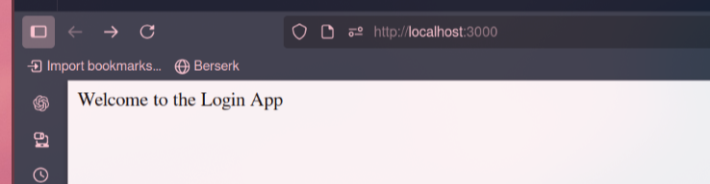

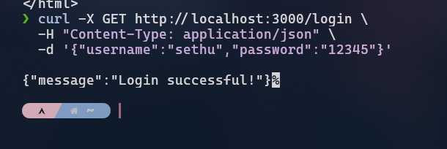

3.
const express = require("express");
const bodyParser = require("body-parser");
const { renderSlot } = require("vue");
const app = express();
app.use(bodyParser.json());
let todos = [];
app.get("/",(req,res) =>{
res.send("To do List");
});
app.post("/todos", (req, res) => {
const { task } = req.body;
todos.push(task);
res.json({ message: "Task added!", todos });
});
app.get("/todos", (req, res) => {
res.json(todos);

});
app.listen(3000, () => console.log("Todo app running on http://localhost:3000"));
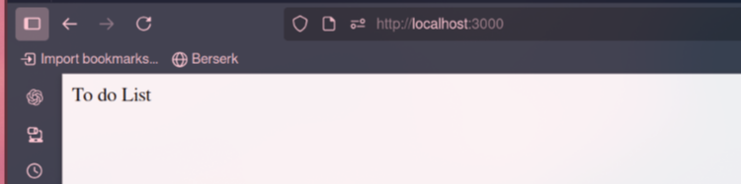
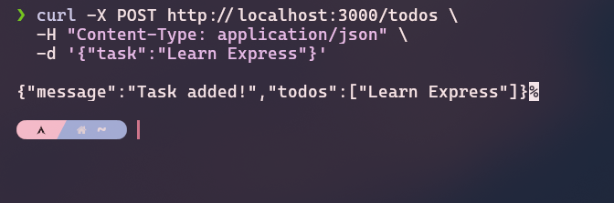
Result
Thus the Express JS implemeted successfully

